CONTACTLESS LIQUID LEVEL CONTROLLER

ABSTRACT:

This ultrasonic level controller comprises of an ultrasonic module which detects precise range by reflection coming ahead of it. This module is interfaced with the serial port of microcontroller. Whenever level distance measured by cm falls below a set point the pump starts since by sensing the ultrasonic module signal coming out from the Tx sensor being reflected from the level and is received by the ultrasonic Rx sensor the output of which is fed to microcontroller.
When the microcontroller receives the signal from ultrasonic receiver it activates the relay through a MOSFET that operated the pump on or off.
The power supply consists of an electronic transformer (230V, 50Hz/12V, 25KHz) which steps down the voltage to 12V AC. This is converted to DC using a Bridge rectifier. The ripples are removed using a capacitive filter and it is then regulated to +5V using a voltage regulator 7805 which is required for the operation of the microcontroller and other components.

BLOCK DIAGRAM

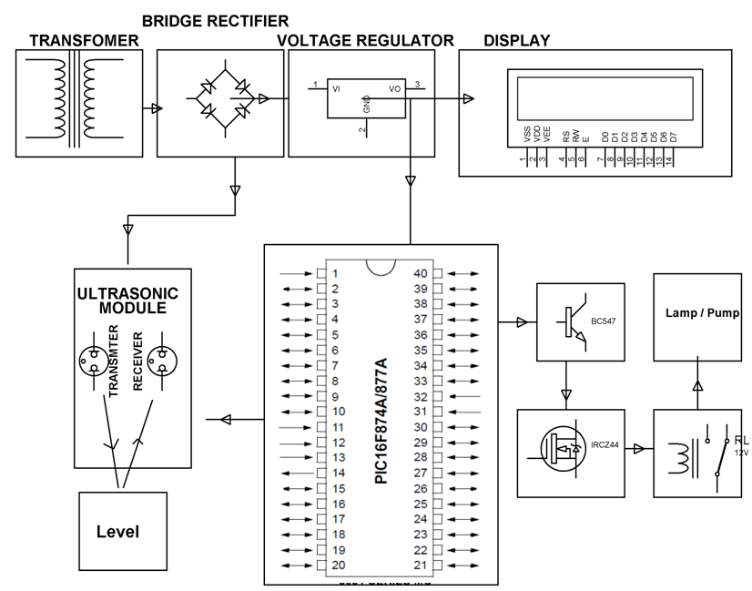
HARDWARE REQUIREMENTS:
PIC Microcontroller unit, LCD (16x2), Ultrasonic module, LED, Transistors, MOSFET, Crystal, Transformer, Diodes, Voltage Regulator, Capacitors, Resistors, Relay, lamp, holder. (Pump optional at extra)

SOFTWARE REQUIREMENTS:

MPLAB, HI-TECH PICC Tool suite

Language: Embedded C Or Assembly

